UNIT- I

Soil biota, soil microbial ecology, types of organisms in different soils; soil microbial biomass; microbial interactions; un-culturable soil biota.

Soil biology

Soil biology is the study of microbial and faunal activity and ecology in soil. Soil life, soil biota, soil fauna, or edaphon is a collective term that encompasses all the organisms that spend a significant portion of their life cycle within a soil profile, or at the soil-litter interface. These organisms include earthworms, nematodes, protozoa, fungi, bacteria and different arthropods. Soil biology plays a vital role in determining many soil characteristics. The decomposition of organic matter by soil organisms has an immense influence on soil fertility, plant growth, soil structure, and carbon storage.

Soil biology involves work in the following areas:
- Modelling of biological processes and population dynamics
- Soil biology, physics and chemistry: Occurrence of physicochemical parameters and surface properties on biological processes and population behavior
- Population biology and molecular ecology: Methodological development and contribution to study microbial and faunal populations; diversity and population dynamics; genetic transfers, influence of environmental factors
- Community ecology and functioning processes: Interactions between organisms and mineral or organic compounds; involvement of such interactions in soil pathogenicity; transformation of mineral and organic compounds, cycling of elements; soil structure
- Complementary disciplinary approaches: That necessarily utilize and involves molecular biology, genetics, ecophysiology, biogeography, ecology, soil processes, organic matter, nutrient dynamics and landscape ecology.

The Soil Biota
Soil biota consist of the microorganisms (archaea, bacteria, fungi and algae), soil animals (protozoa, nematodes, mites, springtails, spiders, insects, and earthworms) and plants (Soil Quality Institute 2001) living all or part of their lives in or on the soil or pedosphere (Fig. 1).
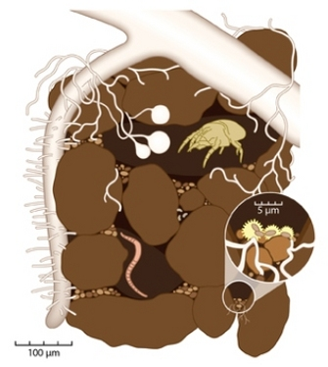

Figure 1: A soil aggregate or ped is a naturally formed assemblage of sand, silt, clay, organic matter, root hairs, microorganisms and their secretions, and resulting pores.

Millions of species of soil organisms exist but only a fraction of them have been cultured and identified. Microorganisms (archaea, bacteria, fungi, algae and cyanobacteria) are members of the soil biota but are not members of the soil fauna. The soil fauna is the collection of all the microscopic and macroscopic animals in a given soil. Soil animals can be conventionally grouped by size classes: macrofauna (cm; enchytraeids, earthworms, macroarthropods), mesofauna (mm; microarthropods, mites and collembolan), and microfauna (µm; protozoa, nematodes) (Figure 2). The size of a soil organism can restrict its location in the soil habitat. Smaller members of the microfauna like nematodes are basically aquatic organisms that live in the thin water films or capillary pores of aggregates preying or grazing on other aquatic microfauna such as amoebas (Figure 1). Soil protozoa are also land-adapted members of aquatic microfauna that can dwell in water films in field moist soils. Water films are created by the adsorption of water to soil particles. Soil has a direct effect on the environmental conditions, habitat and nutrient sources available to the soil biota. The term pedosphere is often used interchangeably with soil and captures the concept that the soil is a habitat where the integration of spheres occurs. These spheres include the lithosphere, atmosphere, hydrosphere, and the biosphere (Brady & Weil 2002) (Figure 3). Numerous biogeochemical processes regulated by soil biota occur in the pedosphere. Studies of the pedosphere range in scale from the field (km) to a soil aggregate (µm to nm).
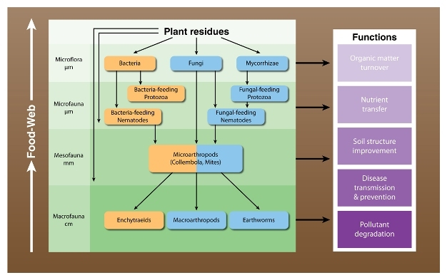

Figure 2: Trophic levels in a soil food web
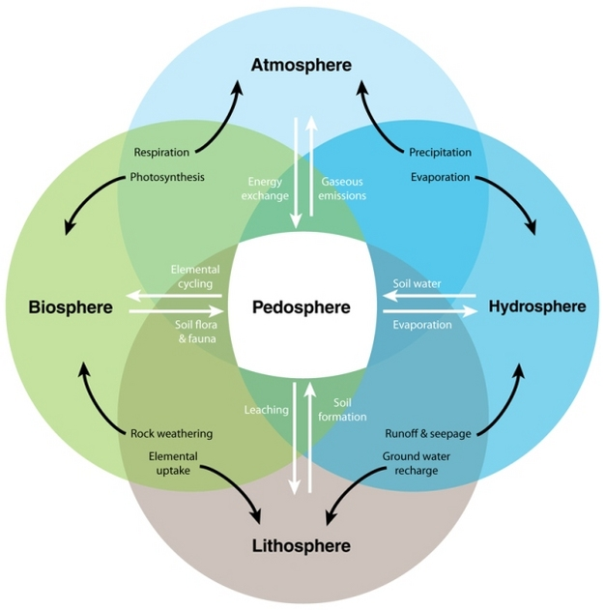

Figure 3: Interactive processes linking the pedosphere with the atmosphere, biosphere, hydrosphere, and lithosphere.

The role of the soil biota in biogeochemical cycles: nutrient transformations, carbon sequestration & greenhouse gases (GHG)s

Soil organisms serve numerous roles in the pedosphere. Their most critical function is the regulation of biogeochemical transformations (Table 1). Five functions mediated by the soil biota are 1) the formation and turnover of soil organic matter (OM) that includes mineralization and sequestration of C, 2) nutrient cycling, 3) disease transmission and prevention, 4) pollutant degradation, and 5) improvement of soil structure (Gupta et al. 1997) (Figure 2). The by-products of metabolic oxidation or reduction of C and N compounds in soils include GHG (Madsen 2008). The dominant soil GHGs consist of: carbon dioxide (CO₂), methane (CH₄), and nitrous oxide (N₂O). Soil management practices such as N fertilization and tillage can stimulate specific microbial activities such as autotrophic nitrification, denitrification and mineralization that regulate GHG emissions (Greenhouse Gas Working Group 2010) by the oxidation and reduction of C and N.
Table 1. Examples of physiological processes catalyzed by microorganisms in biosphere habitats
Process |  | Process
Carbon cycle | Nature of process | Nitrogen cycle | Nature of process
Photosynthesis | Light-driven CO₂ fixation into biomass | N₂ fixation | N₂ gas becomes NH₃
C Respiration | Oxidation of organic C to CO₂ | NH₄⁺ oxidation | NH₃ becomes NO₂⁻, NO₃⁻
Cellulose decomposition | Depolymerization, respiration | Anaerobic NH₄⁺oxidation | NO₂⁻ and NH₃ becomes N₂ gas
Methanogenesis | CH₄ production | Denitrification | NO₃⁻ is used as an electron acceptor and converted to N₂ gas
Aerobic CH₄ oxidation | CH₄ becomes CO₂
Anaerobic CH₄ oxidation | CH₄ becomes CO₂
 |  | Sulphur cycle | Nature of process
 |  | S₂ oxidation | S²⁻ and S⁰ become SO₄²⁻
 |  | SO₄²⁻ reduction | SO₄²⁻ is used as an electron acceptor and converted to N₂ gas
Biodegradation | Nature of process | Other elements | Nature of process
Synthetic organic compounds | Decomposition, CO₂ formation | H₂ oxidation | H₂ is oxidized to H⁺, electrons reduce other substances
Petroleum hydrocarbons | Decomposition, CO₂ formation | Hg methylation & reduction | Organic Hg is formed & Hg²⁺ is converted to Hg
Fuel additives (MTBE) | Decomposition, CO₂ formation | (per)chlorate reduction | Oxidants in rocket fuel & other sources are converted to chloride
Nitroaromatics | Decomposition, CO₂ formation | U reduction | U oxyanion is used as an electron acceptor, therefore immobilized
Pharmaceuticals, personal care products | Decomposition | As reduction | As oxyanion is used as an electron acceptor; therefore toxicity is diminished
Chlorinated solvents | Compounds are chlorinated through respiration in anaerobic habitats | Fe oxidation, acid mine drainage | FeS ores are oxidized, strong acidity is generated
Note: As, arsenic; C, carbon; CH₄, methane; CO₂, carbon dioxide; Fe, iron; FeS, Iron sulphide; H, hydrogen; Hg, mercury; Hg²⁺, mercuric ion; MTBE, methyl tertiary butyl ether; N₂, nitrogen; NH₃, ammonia; NH₄⁺, ammonium; NO₂⁻, nitrite; NO₃⁻, nitrate; S₀,
elemental sulphur; S²⁻, sulphide; SO₄²⁻, sulphate; U, uranium.

The size and composition of the microbial biomass (the combined mass of micro-organisms in the soil) is dependent upon soil properties and the source(s) of C available for energy and cell synthesis. Carbon inputs to the soil vary in their biochemical composition (e.g., their ability to be decomposed) and nutrient content. Carbon turnover, decomposition and microbial activity often lead to increase in OM and soil aggregation (see Aggregates: Model of a Pedosphere). Different ecosystems vary in their potential to support soil organisms (Table 2) and sequester C in OM. Organic C constitutes the chemical backbone of OM and is the energy source for most soil organisms. Microbial decomposition of plant residues and OM provides access to C and nutrients such as N and P required by the majority of living organisms. Mineralization of organic N to ammonium (NH₄⁺) and additions of N fertilizers that contain NH₄⁺ stimulate nitrification a process driven by nitrifying bacteria and archaea that transform NH₄⁺ to nitrate (NO₃⁻) (Maier et al. 2009, van Elsas et al. 2007). Nitrate can then undergo an additional microbially mediated step, denitrification. Denitrifiers include bacteria and archaea (Maier et al. 2009, van Elsas et al. 2007). Both nitrification and denitrification are pathways that produce nitrous oxide (N₂O).

Table 2. Typical number of soil organisms in healthy ecosystems
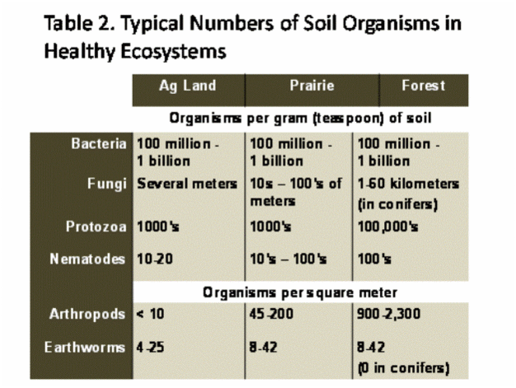

The soil food web consists of the community of organisms that live all or part of their lives in the pedosphere and mediate the transfer of nutrients among the living (biotic) and non-living (abiotic) components of the pedosphere through a series of conversions of energy and nutrients as one organism and or substance is consumed by other organisms (Sylvia et al. 2005). The mesofauna (collembolan, mites) play a role in nutrient turnover by shredding materials into smaller pieces with higher surface area providing greater access for microfauna (bacteria, fungi, mycorrhizae) that recycle the majority of C (Figure 2). All food webs contain several trophic levels or feeding positions in a food chain (Figure 2). The term grazing is used when organic C is obtained from living things. Soil organisms are part of the detrital food chain if their organic C is derived from dead materials. The detrital food chain creates new soil organic matter and cycles nutrients from existing OM. Biological systems and organisms contain fairly constant elemental ratios of carbon:nitrogen:phosphorus:sulfur (C:N:P:S). These ratios and mass balances (net change = input + output + internal change) allow scientists to determine biochemical shifts between organisms or ecosystems.
Most members of the soil fauna are chemoheterotrophs, meaning they obtain C and energy by oxidizing (metabolizing) organic compounds (Sylvia et al. 2005). Carbon sequestration limits the process of mineralization mediated by chemoheterotrophs that produce CO₂.

Arenas of activity
The ability of microorganisms to recycle C can provide indirect health benefits to plant communities. Soils that contain larger amounts of OM and microbial biomass tend to have higher rates of microbial activity and as such, some organisms may have the ability to out compete other organisms including plant pathogens. This type of suppression of plant pathogens is known as general suppression (Sylvia et al. 2005). Soils that contain high levels of OM may also support specific antagonistic microorganisms that have an explicit means of suppressing pathogens such as the production of antibiotics. This is an example of specific suppression. Soils that exhibit such properties are termed suppressive soils.
Microorganisms also interact directly with plants through symbiotic relationships that provide nutrients to plants while supplying C to the microorganism(s). An example of a symbiotic relationship between a soil microbe and a higher plant is the interaction of the bacterium known as arhizobium that induces the formation of nodules on roots of soybean plants in which it fixes N for the plant using carbohydrate supplied by the plant.
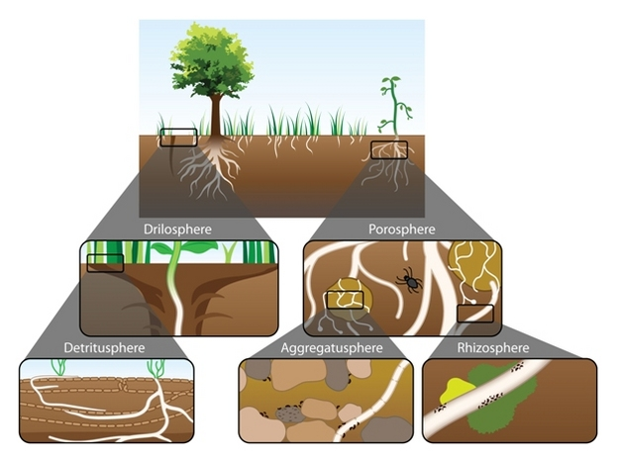

Figure 4: Arenas of activity in soils contain hot spots.
Zones or ecosystems containing areas of activity include the “drilosphere” (the portion of the soil volume influenced by secretions of earthworms), the porosphere (the total pore space), detritusphere (dead plant and soil biota), aggregatusphere (the sum of aggregates) and the rhizosphere.

As an example of the linkages and transport of nutrients among ecosystems in a forest consider the following scenario. Leaves fall to the forest floor. This is followed by the physical breakdown of the leaf by the shredding action mediated by the members of the mesofauna (e.g., mites, collembolans) and subsequent further decomposition by microorganisms. Overtime, the decaying leaf passes through the gut of a worm and is deposited in the drilosphere. Remaining leaf matter in the drilosphere located within an aggregate and additional organic materials contained within the aggregate replenish the supply of N, P, and OM used by soil organisms. These organisms decompose and mineralize detritus and OM providing a source of nutrients to plants when aggregates are part of the rhizosphere of a tree root. The mucilages that are produced by the active microorganisms feeding on detrital leaf matter and other organic materials increase the size and stability of the aggregate ecosystem. In this way, soil organisms release, transform, and relocate resources found in arenas of activity throughout the pedosphere via a number of biogeochemical cycles.

In balanced soil, plants grow in an active and steady environment. The mineral content of the soil and its healthful structure are important for their well-being, but it is the life in the earth that powers its cycles and provides its fertility. Without the activities of soil organisms, organic materials would accumulate and litter the soil surface, and there would be no food for plants. The soil biota includes:
- Megafauna: size range - 20 mm upward, e.g. moles, rabbits, and rodents.
- macrofauna: size range - 2 to 20 mm, e.g. woodlice, earthworms, beetles, centipedes, slugs, snails, ants, and harvestmen.
- Mesofauna: size range - 100 micrometres to 2 mm, e.g. tardigrades, mites and springtails.
- Microfauna and Microflora: size range - 1 to 100 micrometres, e.g. yeasts, bacteria (commonly actinobacteria), fungi, protozoa, roundworms, and rotifers.

Of these, bacteria and fungi play key roles in maintaining a healthy soil. They act as decomposers that break down organic materials to produce detritus and other breakdown products. Soil detritivores, like earthworms, ingest detritus and decompose it. Saprotrophs, well represented by fungi and bacteria, extract soluble nutrients from delitro. The ants (macrofaunas) help by breaking down in the same way but they also provide the motion part as they move in their armies. Also the rodents, wood-eaters help the soil to be more absorbent.

Microbial Biomass

Key points
- Microbial biomass (bacteria and fungi) is a measure of the mass of the living component of soil organic matter.
- The microbial biomass decompose plant and animal residues and soil organic matter to release carbon dioxide and plant available nutrients.
- Farming systems that return plant residues (e.g. no-tillage) tend to increase the microbial biomass.
- Soil properties such as pH, clay, and the availability of organic carbon all influence the size of the microbial biomass.
Background
The microbial biomass consists mostly of bacteria and fungi, which decompose crop residues and organic matter in soil. This process releases nutrients, such as nitrogen (N), into the soil that are available for plant uptake. About half the microbial biomass is located in the surface 10 cm of a soil profile and most of the nutrient release also occurs here (figure 1). Generally, up to 5 % of the total organic carbon and N in soil is in the microbial biomass. When microorganisms die, these nutrients are released in forms that can be taken up by plants. The microbial biomass can be a significant source of N, and in Western Australia can hold 20 – 60 kg N/ha.
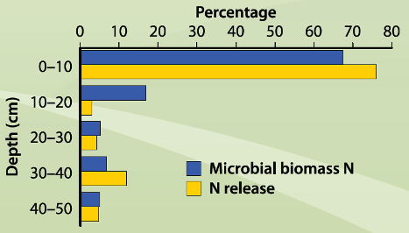

Figure 1: Microbial biomass nitrogen and release of nitrogen decreasing with depth

Microbial biomass is also an early indicator of changes in total soil organic carbon (C). Unlike total organic C, microbial biomass C responds quickly to management changes. In a long term trial at Merredin, no significant change in organic C was detected between stubble burnt or retained plots after 17 years. Microbial biomass C in the same plots had increased from 100 to 150 kg-C/ha (Hoyle et al., 2006a).
In soil the microbial biomass is usually ‘starved’ because soil is too dry or doesn’t have enough organic C. The amount of labile carbon is of particular importance as this provides a readily available carbon energy source for microbial decomposition. Soils with more labile C tend to have a higher microbial biomass.
Important sources of organic carbon as food for the microbial biomass are crop residues and soluble compounds released into the soil by roots (root exudates).

Factors affecting microbial biomass
The microbial biomass is affected by factors that change the water or carbon content of soil, and include soil type, climate and management practices. Rainfall is usually the limiting factor for microbial biomass. Soil properties that affect microbial biomass are clay, soil pH, and organic C (figure 3). Soils with more clay generally have a higher microbial biomass as they retain more water and often contain more organic C (figure 4). A soil pH near 7.0 is most suitable for the microbial biomass.

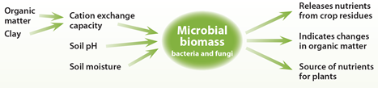

Figure 3: The main soil properties affecting the microbial biomass and factors influenced by it.

Management of crop residues influences microbial biomass as they are one of the primary forms of organic carbon and nutrients used by the microbial biomass. Retaining crop residues rather than burning them provides a practical means of increasing the microbial biomass in soil by increasing the amount of organic carbon available to them (table 1).

Table 1: The effect of 17 years of retaining or burning stubble on microbial biomass carbon at different soil depths at Merredin, WA (Hoyle et al., 2006b).
Soil Depth (cm) | Microbial biomass carbon (kg/ha)
 | Stubble retained | Stubble burnt
0 – 10 | 229 | 165
10 – 20 | 112 | 93
20 – 30 | 69 | 58

Tillage practices that are less disruptive to soil can increase the microbial biomass. Less disruptive tillage increases the microbial biomass by increasing labile carbon in soil (figure 5). These management practices also protect soil aggregates and do not break fungal networks, which are an important habitat for the microbial biomass in soil.
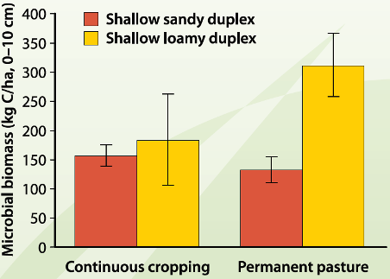

Figure 4: Microbial biomass in soils with different clay contents and under different management. Soils with more clay generally have a higher microbial biomass because they retain more water and often contain more organic carbon.
The type of crops in a rotation can affect the microbial biomass. The residues of legume crops can increase microbial biomass due to their greater N contents. Rotations that have longer pasture phases increase microbial biomass because soil disturbance is reduced (figure 4). This may not be the case in sandy soils, where the lack of clay means organic matter is broken down rapidly. This leaves the microbial biomass ‘starved’.

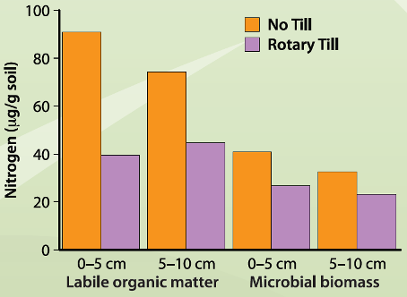

Figure 5: Increased nitrogen content in labile organic matter and the microbial biomass with no-till compared to rotary till in a 9-year field trial at Wongan Hills, WA (Cookson et al., 2008).

Microbial Biomass
Biomass of samples as related to texture
Soil Texture (USDA) | % OM (mean) | Microbial Biomass (μg/g)
Sand | 2.0 | 55
Loamy Sand | 1.5 | 137
Sandy Loam | 1.6 | 106
Silt Loam | 3.2 | 292
Loam | 4.5 | 358
Biomass of samples as related to organic matter
OM Range | Av. Microbial  Biomass (μg/g) | Microbial Biomass  Range (μg/g)
0 to 1.0 | 76 | 10 to 165
1.0 to 2.0 | 130 | 17 to 379
2.0 to 3.0 | 169 | 24 to 418
3.0 to 4.0 | 219 | 119 to 300
4.0 to 5.0 | 345 | 127 to 454
5.0 to 6.0 | 427 | 369 to 506
6.0+ | 613 | 421 to 805

The microbial biomass of soil is defined as the part of the organic matter in the soil that constitutes living microorganisms smaller than the 5-10 um³. It is generally expressed in the milligrams of carbon per kilogram of soil or micrograms of carbon per gram of dry weight of soil. Typical biomass carbon ranges from 1 to 5% of soil organic matter. The degradation of organic compounds, such as industrial chemicals and pesticides, can be monitored by following changes in the soil microbial biomass.
Several methods can and are used to estimate the soil microbial biomass population. They can be summarized as follows:

- Staining and counting the microbial cells.
- The use of physiological parameters such as ATP, respiration, and heat output.
- An application of a soil fumigate and measurement.

Currently employed method is soil fumigate method for measuring the biomass of the soil. The soil is fumigated with chloroform to kill the microbial population. After the microbes are killed by fumigation, cytoplasm is released into the soil environment. The soil microbial biomass carbon is extracted with potassium sulfate on both fumigated and unfumigated soil. The carbon content of the extract is tested and the biomass is calculated based on the difference between the carbon content of fumigated vs. the unfumigated soil. The carbon can also be oxidised by dichromate, but plan on using our automatic carbon analyzer with an IR detector in the future.
A biomass reading is a snapshot picture of the microbial population on the day the sample was tested in the laboratory. It is not a stable number like the CEC or the texture of a soil. The biomass number will change with the environment in which the soil undergoes. After the soil is removed from a field setting, the biomass can and will change with storage conditions of the soil. Recommended storage conditions for biomass samples is 4ºC. Freezing of soil samples is not recommended due to the adverse biocidal effects on the soil microbial biomass. If samples must be frozen, they should be preincubated for 7 to 10 days prior to testing. The drying of soil samples for biomass readings must be strictly avoided. Also, after the sampling procedure takes place, samples should not be exposed to direct sunlight. Experience also indicates the long-term storage under refrigerated conditions in sealed containers can and will affect the biomass results too. Samples reanalyzed after a month or more of storage can have a significant reduction in the biomass reading. I strongly suspect the microbes may have used up the oxygen supply in sealed containers after prolonged storage.

The estimated average contents of Organic Materials (mass and count) per acre in a soil profile formed under grass in a subhumid temperate region can be found in the following

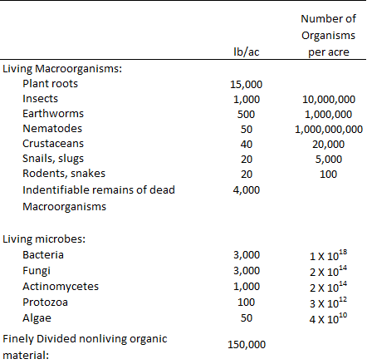

Reference: Troeh, Frederick R., and Louis M. (Louis Milton) Thompson. Soils and Soil Fertility. 6th ed. Ames, Iowa: Blackwell Pub., 2005

Soil Microbial Ecology

Ecology is important for understanding your soil
Soil ecology
Soil ecology is the study of the interactions among soil organisms, and between biotic and abiotic aspects of the soil environment. It is particularly concerned with the cycling of nutrients, formation and stabilization of the pore structure, the spread and vitality of pathogens, and the biodiversity of this rich biological community.
Soil Microbial Ecology
Ecology aims to understand the distribution and abundance of organisms, and their functions in a community. An organism's ecology is moderated by interactions with both the non-living environment and with other organisms. An ecosystem, for example a soil ecosystem, is a community of interacting organisms. Species-rich ecosystems with many interactions are more stable.

What is microbial ecology?
- Microbial ecology is the study of microbes in the environment and their interactions with each other. Microbes are the tiniest creatures on Earth, yet despite their small size, they have a huge impact on us and on our environment.
- Microbial ecology can help answer some of our most practical questions such as "How can we improve our lives?" as well as basic questions such as "Why are we here?"
- Microbial ecology can show us our place in the cosmos -- how life originated and how it evolved, and how we are related to the great diversity of all other organisms.
The study of microbial ecology can help us improve our lives via the use of microbes in environmental restoration, food production, bioengineering of useful products such as antibiotics, food supplements, and chemicals. The study of these bizarre and diverse creatures that are everywhere yet nowhere to be seen is fascinating and a pursuit that appeals to the curiousity and playfulness in us.
Most types of microbes remain unknown. It is estimated that we know fewer than 1% of the microbial species on Earth. Yet microbes surround us everywhere -- air, water, soil. An average gram of soil contains one billion (1,000,000,000) microbes representing probably several thousand species.

Topics in microbial ecology
To find out more about how microbes evolve, about their tremendous diversity, their ecology, their unusual habitats, their role in bioremediation, recycling, food production and biotechnology.

Healthy soils are diverse ecosystems
Healthy soils are complex ecosystems containing many species. Specific soil fungi and bacteria are associated with plant roots. Rhizosphere fungi and bacteria are functionally important to their plants.
Healthy soils have a highly diverse microbiota. Recent research estimates that 1 gram of a typical soil sample contains 10000 species of bacteria or 10¹⁰ bacterial cells per square centimeter (Fierer et al, 2011).

Biodiversity
An estimated 1,000,000 bacterial species exist on this planet, according to the Global Biodiversity Assessment, yet fewer than 4500 have been described. The greatest genetic diversity of life comes from within the world of microorganisms, yet the least is known about them.

Diverse Habitats
Microbes inhabit the widest range of habitats from sub-freezing temperatures, to water hotter than boiling, from the rocks beneath our feet, to the atmosphere miles overhead, to the stuff between our toes, to the tops of mountains and to the deepest ocean trenches.

Microbe Hunting
Hunting for new microbes is not as easy as taking a jeep trip in the outback with a pair of binoculars. By definition, microbes are invisible without the aid of a microscope, so the challenge to find new ones is great. The difficulty is compounded when one does look under the microscope to see two apparently similar bacteria which later prove to be not at all similar. For example: two bacteria may have the same rod shape, but one thrives in the presence of oxygen whereas the other one is killed by oxygen.
Because microbes are so difficult to observe, they are the last organisms to be catalogued with fewer than one percent yet described.

A diverse soil microbiota results in improved soil ecosystem service
Soils with high microbial diversity suppress plant diseases spread in soil. Higher soil bacterial and fungal diversity increases soil functioning including higher soil nutrient cycling, increases soil decomposition rates, and higher plant productivity.
Diverse soils can be disease-suppressive. Increase soil; microbial diversity reduced both the size of a soil bacterial plant pathogen population, and its competititve ability, and therefore also its likelihood of survival (Van Elsas, 2012).
Increase mycorrhizal fungal species diversity causes higher plant shoot biomass, root biomass, increased overall plant phosphate uptake and plant productivity (Van der Heijden et al, 1998, Bevan et al, 2013).
Increased microbial diversity increases bacterial nutrient (nitrogen) cycling rates and wheat straw decomposition rates (Bell et al, 2005, Philippt et al, 2013, Baumann et al, 2013).

The Rhizosphere: A complex and diverse interacting ecoystem.
Plant roots and soil microbiota interact via chemicals secreted by plant roots. Plant root secretions provide rhizosphere fungi and bacteria with abundant carbon-based food. Plant root secretitions can stimulate or suppress soil fungi and bacteria.
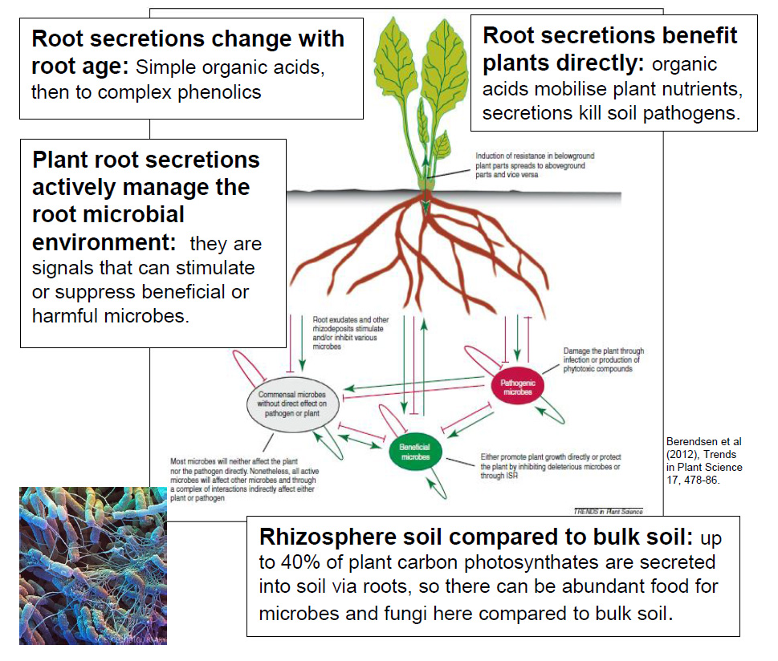

Diversity and stability in microbial populations
Microbes usually occupy subtly different microhabitates (niches) in soil. Some bacteria have resistant spores that can remain in soil to wait for a burst of food availability. If conditions become suitable, the population size of microbes that can consume available food will grow rapidly and exponentially. Soil with high microbial species diversity are more resilient to environmental change because they are more likely to contain species able to grow in any novel conditions.

A diversity of bacterial chemical signalling
Microbes secrete small molecules into their environment, and respond to molecules secreted by others. Some responses to signalling molecules ("quorum sensing") result in adaptations to new conditions, which benefit select groups over others. Signalling molecules from other organisms can block the signal cascade (called "quorum quenching"). Plant roots encourage beneficial associations with certain bacteria and fungi by secreting "elicitor" molecules, these lead to symbiotic associations.

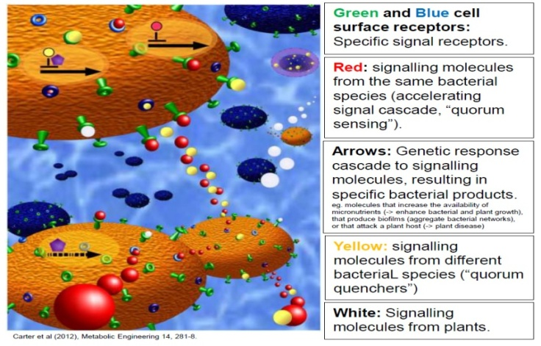

Soil priming
Priming occurs when the addition of modest amounts of soil organic materials have a strong short-term effect on soil microbial activity and organic carbon breakdown. Soil priming occurs naturally when organic matter derived from photosynthesis is pumped into the rhizosphere soil via plant root secretions. Some compounds have significant soil priming effects, even at low concentration.
Addition of organic matter to the soil can cause an exponential increase in specific groups of soil microbes. These can rapidly consume both the organic matter added to the soil plus existing soil organic matter when added material runs out. Most natural organic matter additions into soil are via plant secretions into the soil rhizosphere, rather than plant litter.
Different organic materials have different soil priming effects, because different groups of microbes are stimulated. Simple organic matter additions include sugars and organic acids and cause priming via many microbes. Complex organic matter additions include straw, wood cellulose, and lignin, and cause priming via specialist microbes.
Un-culturable soil biota
Too much bacteria still unculturable
Some bacteria can grow very fast on the available commercial culture-media but most of the bacteria cannot grow on them, even the bacterial cells are viable, are called uncultured or even non-culturable bacteria. The availability of pure culture isolates greatly simplifies investigations of the physiology and roles of bacteria. Initial biochemical and genetic studies in the laboratory can allow more effective formulation of hypotheses, which can then be tested in the natural habitat.
It is fact that most of the bacteria cannot be cultured in the normal laboratory conditions and that is why their contribution in any environment could not be studied. The major hindrance behind this fact is that the scientists are still unable to understand and provide the true environment which they need for their growth. It has been estimated that only 0.1% of the total population of bacteria from any environment has been cultured and 99.9% are still uncultured. Although with the help of high throughput molecular techniques, different communities of bacteria have been analyzed but they could not be cultured on the conventional media plates. It is very obvious that without culturing, their true functions cannot be estimated and cannot be applied in any field. There is dire need to cultivate the uncultured bacteria especially in the field of agriculture. Analysis of biochemical and physical properties of the sample will guide us to cultivate the previously described uncultured bacteria. A few studies have made possible to cultivate some previously uncultured bacteria but still their roles in the specific environment have not been described. Some techniques like long incubation period, sonication, selection of small colonies with magnifying glass, using soil extract, serial dilution, using different kind of media with increasing or decreasing the strength of nutrients have increased the number of culturable bacteria.
It has been estimated that most of the prokaryotes reside in three large habitats: soil, the sedimentary soil subsurface, and water. It is also a fact that there is no space without microorganisms and it is possible that other habitats might contain dense populations, but their numerical contribution to the total number of prokaryotes is small. Due to molecular techniques, in different environments, the number of prokaryotes have been estimated, e.g. in different aquatic environments 10⁴ -10⁷ cells/ml, for forest soils in the top 1 m is 4×10⁷ cells per gram of soil, for other soils; the number of prokaryotes in the top 1 m is 2×10⁹ cells per gram of soil. Therefore, it is obvious from the above data that there is abundant density of bacteria in almost all environments. However, on the other hand, there is disappointing condition that only less than 1% bacteria from natural environments could be cultivated by using conventional culturing techniques consisting of culture media, culture conditions and detecting colonies with naked eyes.
Although, due to availability of different molecular techniques, we have become able to determine some specific gene diversity in any environment but this approach is very limited and not easy for all researchers.
Scientists have also developed an improved culturing methodology by the combination of various factors affecting bacterial growth such as longer incubation, sonication, selection of microcolonies with the help of magnifying lens, increasing the number of inoculation plates of each dilution, using modified half strength R2A agar and some additional modifications.

Sonication technique: Because of the strong binding between cells and soil particulates (including clay), severe cell damage may be the result of breaking these bindings. To extract bacteria from the binding, a physical method of Ultrasonic Treatment is conducted with a ultra-sonicator using a disrupter horn with a tip diameter of 13 mm, on 20 ml suspensions (2 g soil) kept in centrifuge tubes on ice during the treatment. Energy outputs of 40W (approximately 20 pm amplitude) and 55W (40 pm amplitude) were used.
Modified half strength R2A agar: A non-selective medium, R2A agar medium, a modification of Henrici medium (Henrici, 1938), was developed by Reasoner and Geldreich (1985). The soil sample was suspended in 50 mM phosphate buffer (pH 7.0) and spread on plates of 1/5-strength modified R2A agar (0.25 g tryptone, 0.25 g peptone, 0.25 g yeast extract, 0.125 g malt extract, 0.125 g beef extract, 0.25 g Casamino acids, 0.25 g soytone, 0.5 g glucose, 0.3 g soluble starch, 0.2 g xylan, 0.3 g sodium pyruvate, 0.3 g K2HPO4, 0.05 g MgSO4, 0.05 g CaCl2, 15 g agar l21 ) after serial dilution with 50 mM phosphate buffer (pH 7.0). The plates were incubated at 30 ºC for 1 month.

Microbial Association- Microbial Interaction
Microbial Association
From an evolutionary point of view, a behavior is social if it has fitness consequences for both the individual that performs that behavior (the actor) and another individual (the recipient). Hamilton (1964) first categorized social behaviors according to whether the consequences they entail for the actor and recipient are beneficial (increase direct fitness) or costly (decrease direct fitness). Based on Hamilton's definition, there are four unique types of social interactions: mutualism (+/+), selfishness (+/−), altruism (−/+), and spite (−/−) (Table 1). Mutualism and altruism are considered cooperative interactions because they are beneficial to the recipient.
Table 1: Hamilton's classification of the four types of social behaviors
 |  | Effect on recipient
 |  | + | −
Effect  on actor | + | Mutual benefit | Selfishness
 | − | Altruism | Spite

Explaining cooperation remains one of the greatest challenges for evolutionary biology, regardless of whether the behavior is considered mutually beneficial or altruistic. According to classical evolutionary theory, an organism will only behave in ways that maximize its own fitness. Therefore, the origin of cooperative interactions, or actions by individuals that result in other individuals receiving fitness benefits, seems counterintuitive.
Theoretical explanations for the evolution of cooperation can be broadly classified into two categories: direct fitness benefits or indirect fitness benefits. This follows from Hamilton's 1964 insight that individuals gain inclusive fitness directly through their impact on their own reproduction (direct fitness effects), as well as through their impact on the reproduction of individuals with related genes (indirect fitness effects).
Many microbial populations interact and establish associations with each other and with higher organisms. Usually the association is nutritional, although other benefits may accrue and the association can become crucial to the survival of one or both partners. In 1879, de Bary coined the term ‘symbiosis’ to describe any situation where two different organisms live together. Confusingly, some biologists then used the same term specifically to mean the association where both the partners benefited. The term ‘symbiosis’ will be used in its original non-specific sense in this text. There are many sorts of symbiotic relationship such as mutualism, parasitism, amensalism and competition, predation, protocooperation (synergism) and commensalism between the organisms.
Microbial Associations and Fundamentals of their Interactions
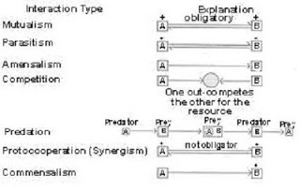

The interactions between the two populations are classified as above according to whether both populations or one of them benefit from the associationship, or one or both populations are negatively affected.
Mutualism and parasitism have been most extensively studied in microbial relationships. In view of their enormous biological, medical, and agricultural implications, the mutualism and parasitism attract greater.
Mutualism

Mutualism describes a relationship in which both associated partners derive some benefit, often a vital one, from their living together. Attempt to summarise the main kinds of mutualistic associations; some of which are trivial and of scientific interest only but others such as Rhizobium legume association, mycorrhizae, coral-microbial association, herbivore-microbial association and lichens are very important, or indispensable, both to the local ecosystem and on a world scale.

Mycorrhizae (Sing. Mycorrhiza)
Mycorrhizae represent a mutualistic symbiosis between the root system of higher plants and fungal hyphae. Frank, who first noted the existence of such a characteristic association in the roots of Cupulifereae in 1885, coined the term ‘mycorrhiza’. Over the last 20 years, basic works conducted by hundreds of researchers from different countries has shown that this association is fundamental and universally occurring. Among the different symbiotic associations between the soil microorganisms and root of plants, mycorrhizae are the most prevalent as they occur on more than 90% of the vascular plants. However, Kumar and Mahadevan (1984) have studied a large number of mycorrhizal associations are found that they are highly influenced by the toxic substances that, when present, are essentially concentrated in the root of plants. Such substances may be alkaloids, phenolics, terpenoids, tannis, stilbenes, etc.
Advantages
1. The fungus derives nutrients via the root of the plant. Sugars formed in the leaves move down the stem as sucrose. Sucrose itself never accumulates in the fungus; it is converted into isomers such as ‘trehalose’ thus resulting in the low sugar concentration.
2. The fungal hyphae act like a massive root hair system, scavenging minerals from the soil and supplying them to the plant.
3. Because of this associationship the plant partner, in addition to the nutritional benefits, develops drought resistance, tolerance to pH and temperature extremes, and greater resistance to pathogens due to ‘phytoalexins’ released by the fungus.

Syntrophy
Syntrophy (Gr. syn=together; trophe-nourishment) is such mutualistic interrelationship between two different microorganisms which together degrade some substances (and conserve energy doing it) that neither could degrade separately. In most cases of syntrophism the nature of a syntrophic reaction involves H₂ gas being produced by one partner and being consumed by the other. Thus, Syntrophy has also been called interspecies hydrogen transfer. Following are some examples of syntrophic associations:
(i) Ethanol fermentation to acetate and eventual production of methane is a good example. Ethanol oxidizing bacterium ferments ethanol producing H₂ which is a valuable electron donor for methanogenesis hence used by a methanogen. When both these reactions are summed, the overall reaction is exergonic (i.e., energy releasing). Actually, the oxidation of ethanol to acetate plus H₂ is energetically unfavourable, the reaction becomes favourable when H₂ produced during it is consumed by the methanogens. In this way, both partners thus use the energy released in the coupled reaction of syntrophic association.
(ii) Oxidation of butyric acid to acetic acid plus H₂ by the fatty acid-oxidizing syntroph Syntrophomonas is another good example. Syntrophomonas does not grow in a pure culture on butyric acid as the energy released during butyric acid oxidation to acetic acid is highly unfavourable to the bacterium. But, if the hydrogen produced in the reaction is immediately utilized by a syntrophic partner (e.g., methanogen), Syntrophomonas grows luxuriantly in mixed-culture with the H₂ consumer.

(iii) Syntrophobacter degrades low molecular weight fatty acids (e.g., propionic acid) to produce H₂ which, if not consumed, inhibits the growth of the producer. When this hydrogen is immediately consumed by Methanospirillum, the syntrophic partner, the growth rates of both Syntrophobacter and Methanospirillum is stimulated, i.e., both partners are benefited.
Association (mutualistic symbiosis):
Microbial Action in the Rumen of Ruminants
The cellulases hydrolyse the cellulose to glucose, and the microorganisms then ferment the glucose to a variety of organic acids such as acetic acid (ethanoate), butyric acid (butyrate) and propionic acid (propionate), so providing energy for their own growth. About 103 dm³ per day of CO₂ and CH₄ are produced as waste products, which are burped out by the animal. Thus the microorganisms present in rumen convert largely indigestible plant material into low molecular weight carbon compounds which can be utilized by the herbivore.

Herbivore-Microbial Association
Plants contain about 30% cellulose (dry weight), the large insoluble inert polysaccharide. It would be very much to the advantage of any herbivore to digest the chemical but, however, the only herbivore to possess the appropriate digestive enzyme, cellulose, is snails. All others, from insects to mammals, do not possess this enzyme and they establish mutualistic associationship with cellulose splitting bacteria and protozoa. These microorganisms generally occupy one of the several sites in the gut, the most advanced condition being that in ruminants. Ruminants, such as cow and sheep, have evolved a unique four chambered ‘stomach’ that has helped establish them as extremely successful herbivores. The rumen volume is large compared with size of the mammal (in the cow it is 80-100 L) so that there being a long resistance time for cellulose decomposition. Plant material is chewed, mixed with saliva and passed to rumen. The rumen contains very numerous microorganisms of which about 90% are cellulose secretors. These may be 104 to 105 protozoa. 1010 – 1011 bacteria and 4 × 104 fungi. The contents of the rumen are continually mixed by slow contractions of the wall at 1-2 minute intervals.

Bioluminescence by Marine Invertebrates and Fish
Some luminescent bacteria (e.g., Photobacterium, Beneckea) establish mutualistic association with marine invertebrates and fish (e.g., Anomalops katoptron). If oxygen is available, these bacteria that normally inhabit some specific organ of the partner, emit blue-green light. The production of light is due to luciferase enzyme that mediates the reaction of reduced flavin mononucleotide (FMNH2), molecular oxygen, and a long-chain aldehyde that produces flavin mononucleotide (FMN) in an electronically excited state. The return of the excited FMN to its ground state results in the emission of light. In turn, the animal partners supply the bacteria with nutrients and protein from competing microorganisms. However, the light emitted by bacteria is used in various ways like sexual mating rituals, search of food sources, warding-off predators, etc.

Coral-Microbial Association
Corals are highly productive and yet live in waters that are very poor in nutrients; the open ocean may have a net productivity of 50 g cm-2 year-1 whereas coral reefs may produce up to 2500 g cm-2 year-1. The reasons for this are still not clear. It is considered that the dinoflagellate symbionts, Gymnodinium microadriaticum and Amphidinium species, are ubiquitous in reed-building corals and they pass atleast 25%, and probably as much as 60 to 70% of their fixed carbon to the animal as glycerol and glucose. They may also take up nitrate from the water and pass it to the coral in a utilizable form alanine. Cyanobacteria are important on reefs in fixing nitrogen, and they may be free living or symbiotic. Bacterial symbionts living on the outside of the coral in mucilage layer have also been implicated in the conservation and rapid recycling of phosphorus and nitrogen to the corals. There are, therefore, a number of potential or actual symbiotic microorganisms which could account for the productivity of coral reefs. Apart from the productivity aspects, Gymnodinium is also very important in depositing skeletal calcium as a result of photosynthesis. The dinoflagellates apparently have to reinfect each generation of corals for they are not passed on during reproduction. How they do this is not known for they have never been found free living in the environment, though they can grow independently in culture.
Lichens
Lichens are remarkable in that under natural conditions the algal-fungal or cyanobacterial-fungal association behaves as a single organism. The fungus (mycobiont) is usually an ascomycete and about 20,000 lichen fungi have been described which is approximately 25% of all known fungi.
There are only some 30 genera of algae (Phycobiont) and cyanobacteria (cyanobiont) known to form lichens. The relationship between the two associates of the lichen thallus is still not fully confirmed, though lichens have been the classic material for the study of microbial mutualistic symbiosis. The Phycobiont/cyanobiont supplies carbohydrate to the mycobiont and the latter may supply minerals to the former. We have no experimental confirmation that the mycobiont supplies minerals to its associates; also, the Phycobiont may be able to absorb its own minerals from the substrate. ‘Good’ laboratory conditions cause the association to break down, whilst adverse conditions help to maintain it. This indicates that the association probably enables the associates to exploit habitat which would be unsuitable when they grow apart. Lichens are considered the ‘pioneer organisms’. They have been claimed to be important in increasing the rate of soil formation from bare rock. They may accelerate physical destruction of the rock by shrinkage and expansion of the thallus, may decompose the rock by wide range of chemical substances such as carbon dioxide (acting as H₂CO₃), various organic acids, and chelating agents. Lichens may accumulate minerals and nitrogen which are eventually released to the primitive soil when the lichen thallus is decayed. Lichens are greatly affected (even killed) by the level of SO₂ present in the atmosphere; their abundance can be used as an indicator of atmospheric pollution. They or their products may be used as food dyes, and indicators (litmus).
Lichens Classifications
Taking mycobionts into consideration, the lichens are classified into three categories:
(a) Ascolichens: Those having ascomycetous mycobiont. Examples: Paltigera, Parmelia, Collema, Graphis, Physcia, Cladonia, etc.
(b) Basidiolichens: Those having basidiomycetous mycobiont. Examples: Cora, Omphalina, etc.
(c) Deuterolichens: Those having deuteromycetous mycobiont. These lichens are very few in number and are mostly sterile in the sense that their fungal associates do not produce spore

Taking, phycobionts into consideration, the lichens are classified into two categories:
(a) Chlorophycophilous: Those having green algal Phycobiont.
(b) Diphycophilous: Those having green algae as well as cyanobacteria in the same thallus.Those lichens that have only blue green bacteria (cyanobacteria) and fungal partner in their thalli are called cyanophillous.

Taking morphology into account, lichens are classified into three forms:
(a) Crustose: Crust-like, the crusts are so closely attached to the substratum by the whole of its lower surface that is very difficult to dissociate them without breaking. Example – Lecidea, Graphis, Verrucaria, etc.
(b) Foliose: Leaf-like; adhere to the substratum only at definite points by means of certain outgrowths called ‘rhizines’. Ex-Gyrophora. Peltigera, Parmelia, Physcia, Collema, etc.
(c) Fruticose: Shrubby, generally upright in habit; some are pendent, i.e., hang from the twigs and branches of the trees. Examples – Cladonia, Ramalina, Evernia, etc. (shrubby) and Usnea barbata (pendent).
Anatomically, lichens can be classified into two types:
(a) Homolomerous: When algal/cyanobacterial counterpart scattered irregularly but uniformly among the fungal counterparts within the thallus; no any definite cortical layer.
(b) Heteromerous: Thallus with remarkable differentiation into zones: algal/cyanobacterial counterpart contained to a particular zone or layer.

Parasitism
Parasitism represents the symbiotic associationship between two living organisms and is of advantage to one of the associates (parasite) but is harmful to the other (host) to a greater or lesser extent. The parasites may be destructive or balanced. The former destroy the host cells in their later stages of development whereas the latter fulfil their demands from the host in such a way that the host cells are not destroyed but continue to live
Facultative and Obligate Parasites.
Associations would be easy to describe if organisms always behaved in the same way. Unfortunately, they do not. Many microorganisms, for instance, can survive as both parasites and saprophytes. The fungus Ceratocytstis ulmi, which causes Dutch elm disease (Minnesota elm trees), kills the tree and then lives saprophytically on its dead remains. Such an organism which mostly lives as saprophyte but seldom holds the charge of a parasite is referred to as facultative parasite. In contract, downy mildews, powdery mildews, etc. only grow on live protoplasm of the host plant in nature. Such as organism which cannot live elsewhere except on the living protoplasm of its host in nature is called obligate parasite (biotroph). Facultative and obligate parasites often differ in their pathogenic effects, i.e., in their ability to injure the host. Since obligates are restricted to living organisms, their effects on the host are often less severe, although the host may show less vigorous growth. In contrast, facultative parasites which have only recently acquired a host, tend to be more damaging.
Mycoparasitism
When one fungus parasitizes the other, the act is referred to as ‘mycoparasitism’. This term has been generally used interchangeably with ‘hyperperasitism’. ‘direct parasitism’ or ‘interfungus parasitism’. This incitant is generally called ‘mycoparasite’ or ‘hyperparasite’. Mycoparasitism has been classified into two main groups on the basis of nutritional relationship of parasite with host: necrotrophic and biotrophic.
(a) Necrotrophic Mycroparasitism
The necrotrophic (destructive) parasite makes contact with its host, excretes a toxic substance which kills the host cells and utilizes the nutrients that are released.

(b) Biotrophic Mycoparasitism
The Biotrophic (balanced) parasite is able to obtain its nutrients from the living host cells, a relationships that normally exists in Nature. The Mycroparasitism is of common occurrence and examples can be found among all the groups of fungi from chytrids (fungi, a lower types under phylum Chytridiomycota) to higher.
A three member mycoparasitic associationship has also been reported in which chytridium parasiticum is parasite on Chytridium subercrelatum which, too parasitizes Rhizidium richmondense, another chytrid (Willoughby 1956).
The biological control of plant diseases has recently become an area intensive research in view of the hazardous impact of pesticides and other agro-chemical on the ecosystem. Amongst the biological agents, the mycoparasites have attained a significant position. It has been suggested that efforts should be made to investigate the biological control of plant diseases through parasitism and predation. Therefore, the mycologists and plant pathologists are searching for new mycoparasites because the greater number of these the greater would be the chance of exploiting them as agents for biological control. Trichoderma is an important example.
New terms for parasites
The belief that the obligate parasites cannot be grown in laboratory on artificial culture media came at stake when after reports poured in recent years in which there are claims to grow successfully some obligate parasites on culture media. This has prompted the biologists to propose new terminologies in this respect.
Blotroph: A parasite which always obtains its food from living tissues regardless of the ease with which it can be cultured in the laboratory on artificial media, is referred to as a biotroph. The term ‘biotroph’ is now being used for obligate parasites because some of them have been successfully cultured in the laboratory during past few decades.
Hemibiotroph
A parasite is called Hemibiotroph if it attacks living in the same way as the biotroph but continues growing and reproducing even after the living tissues are dead. Hemibiotroph, infact represent facultative saprophytes.
Necrotroph
A parasite, when it kills living of the host in advance of penetration during infection and then obtains its food as a saprophyte, is called a nectotroph. Necrotrophs represent the facultative parasites and are also referred to as perthotrophs or perthophytes.
Amensalism
Amensalism (from the Latin for not at the same table) refers to such an interaction in which one microorganism releases a specific compound has a negative effect on another microorganism. That is, the Amensalism is a negative microbe-microbe interaction. Some important examples are:

i. Antibiotic Production by a microorganism and inhibiting or killing of other microorganism susceptible to that antibiotic is the important example of Amensalism. Concentrations of such antibodies in the bulk of soil or water are certainly small, though there could be a large enough quantity on a micro-habitat scale to give inhibition of nearby microorganisms. The antibiotics reduce the saprophytic survival ability of pathogenic microorganism in soil. The attini ant-fungal mutualistic relationship is promoted by antibiotic producing bacteria (e.g., Streptomyces) that are maintained in the fungal gardens (see box). In this case, streptomyces produces an antibiotic which controls Escovopsis, a persistent parasitic fungus, which can destroy the ant’s fungal garden.
ii. Production of ammonia by some microbial population is deleterious to other microbial population. Ammonia is produced during the decomposition of proteins and amino acids. A high concentration of ammonia is inhibitory to nitrate oxidizing populations of Nitrobacter.

Competition
In contrast to the positive interactions of mutualism and synergism, competition represents a negative relationship between two populations in which both populations are adversely affected with respect to their survival and growth. In this case, the microbial populations compete for a substance which is in short supply. Competition results in the establishment of dominant microbial population and the exclusion of population of unsuccessful competitors. During decomposition of organic matter the increase in number and activity of microorganisms put heavy demand on limited supply of oxygen, nutrients, space etc. The microbes with weak saprophytic survival ability are unable to compete with other soil saprophytes for these requirements and either perish or become dormant by forming resistant structures.
Predation
Predation typically occurs when one microorganism, the predator, engulfs and digests other microorganisms, the prey, and the former derives nutrition from the latter. In microbial fraternity, however, the distinction between predation and parasitism is not sharp. The interaction between Bdellovibrio bacteria and other small gram-negative bacteria is considered by some as predation but by others as parasitism. Bdellovibrio is apparently quite widespread in aquatic habitats and attacks other bacteria, normally gram-negative ones by boring a hole in the wall, entering the bacterium and causing lysis with the eventual release of many small Vibrio-shaped bacteria. The major microbial predators are the protozoa which may engulf bacteria and more rarely algae and other protozoa. These systems have been used extensively in models and simulations of predator prey-relationship. In the simplest from the protozoan population (e.g., Tetrahymena) is limited by its bacterial food (e.g., Klebsiella) and numbers of both prey and predator show cyclic oscillations. Another such example is of Didinium-paramecium (both protozoa) relationships. Didinium preys on the paramecium until the population of the later becomes extinct. Lacking a food source, the Didinium population also becomes extinct. If a few members of the paramecium population are able to hide and escape predation by the Didinium, then the paramecium population recovers following the extinction of the Didinium. Thus a cyclic oscillation can occur in the population of these two protozoans. Predatory fungi exist and have been considered as possible biocontrol agents for some diseases of plants caused by soil microorganism. Nematodes and protozoa may be trapped by a variety of net-like-hyphae, sticky surface and nooses. The organism is the invaded by hyphae and digested.

Protocooperation (synergism)
Protocooperation (or synergism), like mutualism, represents an association between two microbial population in which both population benefit from each other, but it differs from the mutualism in that the association is not ‘obligatory’. Both synergistic populations of microbes are able to survive in their natural environment on their own. Protocooperation or synergism allows microbial population to perform metabolic activities such as synthesis of a product which neither population could perform alone.
Following are few examples:
(i) The Desulfolvibrio bacteria supply H2S and CO2 to Chlorobium bacteria and, in turn, the Chlorobium bacteria make sulphate (SO4) and organic material available to Desulfovibrio. Thus the mixture of the two bacterial populations produce much more cellular material than either alone.
(ii) Nocardia population metabolizes cyclohexane resulting in degradation products that are used by Pseudomonas population. The Pseudomonas population. The pseudomonas species produce biotin and growth factors that are required for the growth of Nocardia.
(iii) Azotobacter population present in soil fixes atmospheric nitrogen if they have a sufficient source of organic compounds. Other soil bacterial populations such as cellulomones are able to utilize the fixed form of nitrogen and provide the Azotobacter population with needed organic compounds.
Commensalism
Commensalism represents a relationship between two microbial populations in which one is benefit and the other remains unaffected (i.e., neither benefit nor harmed). Thus the commensalism is a unidirectional relationship between two microbial populations, It is quite common, frequently based on physical or chemical modifications of the habitat, and is usually not ‘obligatory’ for the two population involved. Commensalistic association is often established when one microbial population, during the course of its normal growth metabolism, modifications the habitat in such a way that the other population is benefited.
Following are some examples:
(i) A disease causing microbial population when a lesion on the surface, it creates an entry-passage for other microbial population that otherwise could not enter and grow in the host tissues. For convenience, Mycobacterium leprae, the causative agent of leprosy, open lesions on the body-surface and thus allow other pathogens to establish secondary infections.
(ii) When facultative anaerobes utilize oxygen and lower the oxygen content, they create anaerobic habitat which suits the growth of obligate anaerobes because the latter benefit from the metabolic activities of the facultative anaerobes in such a habitat. On the contrary, the facultative anaerobes remain unaffected. The occurrence of obligate anaerobes within habitats of predominantly aerobic character, such as the oral cavity, is dependent on such commensal relationship.
(iii) Population of Mycobacterium vaccae, while growing on propane cometabolizes (gratuitously oxidizes) cyclohexane to cyclohexanone which is then used by other bacterial population, e.g., Pseudomonas. The latter population is thus benefited since it is unable to oxidise cyclohexane to cyclohexanone. Mycobacterium remains unaffected since it does not assimilate the cyclohexanone.
Cometabolism
Cometabolism is the process in which one organism growing on a particular substrate gratuitously oxidizes (i.e., oxidizes without any motive) a second substrate which is of no use for it. The oxidation products, however, are well used by other organism.
An Example of Commensalism based on cometabolism
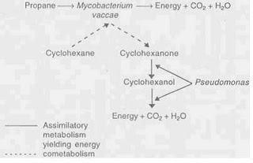

Some microbial populations create Commensalistic habitat by detoxifying compounds by immobilization. Leptothrix bacteria deposite manganese on their surface. In this way, they reduce manganese concentration in the habitat thus permitting the growth of other microbial populations. If Leptothrix do not act so, the manganese concentration would be toxic to other microbial population.

Soil Microbiology
Soil microbiology is the study of organisms in soil, their functions, and how they affect soil properties (their activities and ecology in soil). It is believed that between two and four billion years ago, the first ancient bacteria and microorganisms came about in Earth's primitive seas. These bacteria could fix nitrogen, in time multiplied and as a result released oxygen into the atmosphere. This release of oxygen led to more advanced microorganisms. Microorganisms in soil are important because they affect the structure and fertility of different soils. Soil microorganisms can be classified as bacteria, actinomycetes, fungi, algae, and protozoa. Each of these groups has different characteristics that define the organisms and different functions in the soil it lives in.
Soil is the most abundant ecosystem on Earth, but the vast majority of organisms in soil are microbes, a great many of which have not been described. There may be a population limit of around one billion cells per gram of soil, but estimates of the number of species vary widely. One estimate put the number at over a million species per gram of soil, although a later study suggests a maximum of just over 50,000 species per gram of soil. There are more microbes in a teaspoon of soil than there are people on the earth. Soils contain about 8 to 15 tons of bacteria, fungi, protozoa, nematodes, earthworms, and arthropods. The total number of organisms and species can vary widely according to soil type, location, and depth.

Table 1: Relative number and biomass of microbial species at 0–6 inches (0–15 cm) depth of soil
Microorganisms | Number / g soil | Biomass (g/m²)
Bacteria | 10⁸ –10⁹ | 40–500
Actinomycetes | 10⁷ –10⁸ | 40–500
Fungi | 10⁵ –10⁶ | 100–1500
Algae | 10⁴ –10⁵ | 1–50
Protozoa | 10³ –10⁴ | Varies
Nematodes | 10² –10³ | Varies

The soil is home to a large proportion of the world's biodiversity. The links between soil organisms and soil functions are observed to be incredibly complex. The interconnectedness and complexity of this soil ‘food web’ means any appraisal of soil function must necessarily take into account interactions with the living communities that exist within the soil. We know that soil organisms break down organic matter, making nutrients available for uptake by plants and other organisms. The nutrients stored in the bodies of soil organisms prevent nutrient loss by leaching. Microbial exudates act to maintain soil structure, and earthworms are important in bioturbation. However, we find that we don't understand critical aspects about how these populations function and interact. The discovery of glomalin in 1995 indicates that we lack the knowledge to correctly answer some of the most basic questions about the biogeochemical cycle in soils. We have much work ahead to gain a better understanding of how soil biological components affect us and the biosphere.
In balanced soil, plants grow in an active and steady environment. The mineral content of the soil and its heartiful structure are important for their well-being, but it is the life in the earth that powers its cycles and provides its fertility. Without the activities of soil organisms, organic materials would accumulate and litter the soil surface, and there would be no food for plants. The soil biota includes:
- Megafauna: size range - 20 mm upward, e.g. moles, rabbits, and rodents.
- Macrofauna: size range - 2 to 20 mm, e.g. woodlice, earthworms, beetles, centipedes, slugs, snails, ants, and harvestmen.
- Mesofauna: size range - 100 micrometres to 2 mm, e.g. tardigrades, mites and springtails.
- Microfauna and Microflora: size range - 1 to 100 micrometres, e.g. yeasts, bacteria (commonly actinobacteria), fungi, protozoa, roundworms, and rotifers.
Of these, bacteria and fungi play key roles in maintaining a healthy soil. They act as decomposers that break down organic materials to produce detritus and other breakdown products. Soil detritivores, like earthworms, ingest detritus and decompose it. Saprotrophs, well represented by fungi and bacteria, extract soluble nutrients from detritus. The ants (macrofaunas) help by breaking down in the same way but they also provide the motion part as they move in their armies. Also the rodents, wood-eaters help the soil to be more absorbent.

Soil life table (microbial classification)
This table is a resume of soil life, coherent with prevalent taxonomy.
Domain | Kingdom | Phylum | Class | Order | Family | Genus
Prokaryote | Bacteria | Proteobacteria | Beta Proteobacteria | Nitrosomonadales | Nitrosomonadaceae | Nitrosomonas
Prokaryote | Bacteria | Proteobacteria | Alpha Proteobacteria | Rhizobiales | Bradyrhizobiaceae | Nitrobacter
Prokaryote | Bacteria | Proteobacteria | Alpha Proteobacteria | Rhizobiales | Rhizobiaceae | Rhizobium
Prokaryote | Bacteria | Proteobacteria | Gamma Proteobacteria | Pseudomonadales | Azotobacteraceae | Azotobacter
Prokaryote | Bacteria | Actinobacteria | Actinobacteria
Prokaryote | Bacteria | Cyanobacteria (Blue-green algae)
Prokaryote | Bacteria | Firmicutes | Clostridia | Clostridiales | Clostridiaceae | Clostridium
Eukaryote | Fungi | Ascomycota | Eurotiomycetes | Eurotiales | Trichocomaceae | Penicillium
Eukaryote | Fungi | Ascomycota | Eurotiomycetes | Eurotiales | Trichocomaceae | Aspergillus
Eukaryote | Fungi | Ascomycota | Sordariomycetes | Hypocreales | Nectriaceae | Fusarium
Eukariote | Fungi | Ascomycota | Sordariomycetes | Hypocreales | Hypocreaceae | Trichoderma
Eukaryote | Fungi | Basidiomycota | Agaricomycetes | Cantharellales | Ceratobasidiaceae | Rhizoctonia
Eukaryote | Fungi | Zygomycota | Zygomycetes | Mucorales | Mucoraceae | Mucor
Eukaryote | Chromalveolata | Heterokontophyta | Bacillariophyceae (Diatomea algae)
Eukaryote | Chromalveolata | Heterokontophyta | Xanthophyceae (Yellow-green algae)
Eukaryote | Chromalveolata | Ciliophora
Eukaryote | Amoebozoa
Eukaryote | Plantae | Chlorophyta (green algae) | Chlorophyceae
Eukaryote | Animalia | Nematoda
Eukaryote | Animalia | Rotifer
Eukaryote | Animalia | Tardigrada
Eukaryote | Animalia | Arthropoda | Entognatha | Collembola
Eukaryote | Animalia | Arthropoda | Arachnida | Acarina
Eukaryote | Animalia | Arthropoda | Arachnida | Pseudoscorpionida
Eukaryote | Animalia | Arthropoda | Insecta | Choleoptera (larvae)
Eukaryote | Animalia | Arthropoda | Insecta | Coleoptera | Carabidae (Ground beetles)
Eukaryote | Animalia | Arthropoda | Insecta | Coleoptera | Staphylinidae (Rove beetle)
Eukaryote | Animalia | Arthropoda | Insecta | Diptera (larvae)
Eukaryote | Animalia | Arthropoda | Insecta | Hymenoptera | Formicidae (Ant)
Eukaryote | Animalia | Arthropoda | Chilopoda (Centipede)
Eukaryote | Animalia | Arthropoda | Diplopoda (Millipede)
Eukaryote | Animalia | Arthropoda | Malacostraca | Isopoda (woodlouse)
Eukaryote | Animalia | Annelida | Clitellata | Haplotaxida | Enchytraeidae
Eukaryote | Animalia | Annelida | Clitellata | Haplotaxida | Lumbricidae
Eukaryote | Animalia | Mollusca | Gasteropoda

Bacteria
Bacteria are single-cell organisms and the most numerous denizens of agriculture, with populations ranging from 100 million to 3 billion in a gram. They are capable of very rapid reproduction by binary fission (dividing into two) in favourable conditions. One bacterium is capable of producing 16 million more in just 24 hours. Most soil bacteria live close to plant roots and are often referred to as rhizobacteria. Bacteria live in soil water, including the film of moisture surrounding soil particles, and some are able to swim by means of flagella. The majority of the beneficial soil-dwelling bacteria need oxygen (and are thus termed aerobic bacteria), whilst those that do not require air are referred to as anaerobic, and tend to cause putrefaction of dead organic matter. Aerobic bacteria are most active in a soil that is moist (but not saturated, as this will deprive aerobic bacteria of the air that they require), and neutral soil pH, and where there is plenty of food (carbohydrates and micronutrients from organic matter) available. Hostile conditions will not completely kill bacteria; rather, the bacteria will stop growing and get into a dormant stage, and those individuals with pro-adaptive mutations may compete better in the new conditions. Some gram-positive bacteria produce spores in order to wait for more favourable circumstances, and gram-negative bacteria get into a "nonculturable" stage. Bacteria are colonized by persistent viral agents (bacteriophages).
From the organic gardener's point of view, the important roles that bacteria play are:

Nitrification
Nitrification is a vital part of the nitrogen cycle, wherein certain bacteria (which manufacture their own carbohydrate supply without using the process of photosynthesis) are able to transform nitrogen in the form of ammonium, which is produced by the decomposition of proteins, into nitrates, which are available to growing plants, and once again converted to proteins.

Nitrogen fixation
In another part of the cycle, the process of nitrogen fixation constantly puts additional nitrogen into biological circulation. Azotobacter, Azospirillum, Agrobacterium, Gluconobacter, Flavobacterium and Herbaspirillum are all examples of free-living, nitrogen-fixing bacteria, often associated with non-legumes. Some other that live in close symbiosis with leguminous plants, such as rhizobia. These bacteria form colonies in nodules they create on the roots of peas, beans, and related species. These are able to convert nitrogen from the atmosphere into nitrogen-containing organic substances.

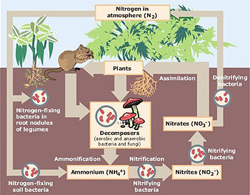

The nitrogen cycle

Denitrification
While nitrogen fixation converts nitrogen from the atmosphere into organic compounds, a series of processes called denitrification returns an approximately equal amount of nitrogen to the atmosphere. Denitrifying bacteria tend to be anaerobes, or facultatively anaerobes (can alter between the oxygen dependent and oxygen independent types of metabolisms), including Achromobacter and Pseudomonas. The putrification process caused by oxygen-free conditions converts nitrates and nitrites in soil into nitrogen gas or into gaseous compounds such as nitrous oxide or nitric oxide. In excess, denitrification can lead to overall losses of available soil nitrogen and subsequent loss of soil fertility. However, fixed nitrogen may circulate many times between organisms and the soil before denitrification returns it to the atmosphere. The diagram below illustrates the nitrogen cycle.

Actinobacteria
Actinobacteria are critical in the decomposition of organic matter and in humus formation, and their presence is responsible for the sweet "earthy" aroma associated with a good healthy soil. They require plenty of air and a pH between 6.0 and 7.5, but are more tolerant of dry conditions than most other bacteria and fungi.

Actinomycetes
Actinomycetes are soil microorganisms. They are a type of bacteria. They are similar to both bacteria and fungi, and have characteristics linking them to both groups. Actinomycetes are often believed to be the missing evolutionary link between bacteria and fungi, but they have many more characteristics in common with bacteria than they do fungi.

Similar to bacteria
Actinomycetes are similar to bacteria because they, like bacteria, are prokaryotic, are sensitive to antibacterial and affected in the same way that bacteria is by them. Actinomycetes can hardly be distinguished from bacteria at its early stages because of how much they resemble bacteria in size, shape and gram-staining properties. Gram staining is a common technique used to classify organisms into two main groups: Gram-positive and Gram-negative, by staining organisms to distinguish its cell wall properties. Gram-positive means that the cell has a thin, penetrable cell wall and gram-negative means the opposite, that the cell wall is thick and difficult to penetrate. Cell wall properties can help distinguish different types of microorganisms from each other.

Similar to fungi
Actinomycetes are most commonly linked to fungi, but they do share some characteristics with fungi. Actinomycetes are similar to fungi by their shape and branching properties, spore formation, which related to how fungi and actinomycetes reproduce by forming spores and duplicating.

Ability to produce antibiotics
One of the most notable characteristics of the actinomycetes is their ability to produce antibiotics. Streptomycin, neomycin, erythromycin and tetracycline are only a few examples of the antibiotics derived from actinomycetes. Streptomycin is used to treat tuberculosis and infections caused by certain bacteria and neomycin is used to reduce the risk of bacterial infection during surgery. Erythromycin is a very important antibiotic that is used to treat certain infections caused by bacteria, such as bronchitis; pertussis (whooping cough); pneumonia; and ear, intestine, lung, urinary tract, and skin infections. This ability to produce these useful antibiotics is the basis of our entire pharmaceutical industry and has saved human lives.

Fungi
Next to bacteria, fungi are abundant in soil population compared to other microorganisms. Fungi are important in the soil as food sources for other, larger organisms, pathogens, beneficial symbiotic relationships with plants or other organisms and help to reduce crop residues and biochemically process nutrients to improve the soil they inhabit. Fungi can be split into different species based on primarily on the size, shape and color of their spores, which are used to reproduce.
A gram of garden soil can contain around one million fungi, such as yeasts and moulds. Fungi have no chlorophyll, and are not able to photosynthesise; besides, they cannot use atmospheric carbon dioxide as a source of carbon, therefore they are chemo-heterotrophic, meaning that, like animals, they require a chemical source of energy rather than being able to use light as an energy source, as well as organic substrates to get carbon for growth and development.
Many fungi are parasitic, often causing disease to their living host plant, although some have beneficial relationships with living plants, as illustrated below. In terms of soil and humus creation, the most important fungi tend to be saprotrophic; that is, they live on dead or decaying organic matter, thus breaking it down and converting it to forms that are available to the higher plants. A succession of fungi species will colonise the dead matter, beginning with those that use sugars and starches, which are succeeded by those that are able to break down cellulose and lignins.
Fungi spread underground by sending long thin threads known as mycelium throughout the soil; these threads can be observed throughout many soils and compost heaps. From the mycelia the fungi is able to throw up its fruiting bodies, the visible part above the soil (e.g., mushrooms, toadstools, and puffballs), which may contain millions of spores. When the fruiting body bursts, these spores are dispersed through the air to settle in fresh environments, and are able to lie dormant for up to years until the right conditions for their activation arise or the right food is made available.

Factors that influence fungi growth
Most of the environmental factors that influence the growth and distribution of bacteria and actinomycetes also influence fungi. The quality as well as quantity of organic matter in the soil has a direct correlation to the growth of fungi, because most fungi consume the organic matter for nutrition. Fungi thrive in acidic environments, while bacteria and actinomycetes cannot survive in acid, which results in an abundance of fungi in acidic areas. Fungi also grows well in dry, arid soils because fungi are aerobic, or dependent on oxygen, and the higher the moisture content in the soil, the less oxygen is present for fungi.

Mycorrhizae
Those fungi that are able to live symbiotically with living plants, creating a relationship that is beneficial to both, are known as Mycorrhizae (from myco meaning fungal and rhiza meaning root). Plant root hairs are invaded by the mycelia of the mycorrhiza, which lives partly in the soil and partly in the root, and may either cover the length of the root hair as a sheath or be concentrated around its tip. The mycorrhiza obtains the carbohydrates that it requires from the root, in return providing the plant with nutrients including phosphorus and moisture. Later the plant roots will also absorb the mycelium into its own tissues.
Beneficial mycorrhizal associations are to be found in many of our edible and flowering crops. Shewell Cooper suggests that these include at least 80% of the brassica and solanum families (including tomatoes and potatoes), as well as the majority of tree species, especially in forest and woodlands. Here the mycorrhizae create a fine underground mesh that extends greatly beyond the limits of the tree's roots, greatly increasing their feeding range and actually causing neighbouring trees to become physically interconnected. The benefits of mycorrhizal relations to their plant partners are not limited to nutrients, but can be essential for plant reproduction: In situations where little light is able to reach the forest floor, such as the North American pine forests, a young seedling cannot obtain sufficient light to photosynthesise for itself and will not grow properly in a sterile soil. But, if the ground is underlain by a mycorrhizal mat, then the developing seedling will throw down roots that can link with the fungal threads and through them obtain the nutrients it needs, often indirectly obtained from its parents or neighbouring trees.
David Attenborough points out the plant, fungi, animal relationship that creates a "Three way harmonious trio" to be found in forest ecosystems, wherein the plant/fungi symbiosis is enhanced by animals such as the wild boar, deer, mice, or flying squirrel, which feed upon the fungi's fruiting bodies, including truffles, and cause their further spread (Private Life Of Plants, 1995). A greater understanding of the complex relationships that pervade natural systems is one of the major justifications of the organic gardener, in refraining from the use of artificial chemicals and the damage these might cause.
Recent research has shown that arbuscular mycorrhizal fungi produce glomalin, a protein that binds soil particles and stores both carbon and nitrogen. These glomalin-related soil proteins are an important part of soil organic matter.

Algae
Algae can make its own nutrients through a process known as photosynthesis. Photosynthesis is when light energy is converted to chemical energy that can be stored as nutrients. For algae to grow, it must be exposed to areas of light because photosynthesis requires light, so algae is typically distributed evenly wherever sunlight and moderate moisture is available. Algae, however, do not have to be on the soil surface or directly exposed to sun rays, but it can live below the soil surface as long as the algae has uniform temperature and moisture conditions. Bacteria are not the only organism that can fix nitrogen, because algae are capable of performing nitrogen fixation as well.

Types
Algae can be split up in to three main groups: the Cyanophycease, the Chlorophycease, and the Bacillariacease. The Cyanophycease contain chlorophyll (photosynthetis pigments- chlorophyll-a and β-carotene, and other pigments: red- phycoenthrin, blue- phycocyanin), which is the molecule that absorbs sunlight and uses that energy to make carbohydrates from carbon dioxide and water, and also pigments that make it blue-green to violet in color. The Chlorophycease (including filamentous forms, and macroscopic seaweeds) usually only has chlorophyll in it which makes it green, and the Bacillariacease contains chlorophyll as well as pigments that make the algae brown in color (chlorophyll a and c and a pigment called fucoxanthin- brown colour, eg, Sargassum and Fucales, the longest sea algae).

Blue-green algae and nitrogen fixation
Blue-green algae, or Cyanophycease, are the algae that are responsible for nitrogen fixation. The amount of nitrogen fixed by these algae depends more on physiological and environmental factors rather than the organism’s abilities. Some of these factors include intensity of sunlight, concentration of inorganic and organic nitrogen sources, and temperature and stability of the environment.

Protozoa
Protozoa are eukaryotic organisms which are some of the first microorganisms to develop a means of sexual reproduction, which is a huge evolutionary step from duplication of spores, like many of the other soil microorganisms depend on. Protozoa can be split up into three categories: flagellates, amoebae, and ciliates.

Flagellates
Flagellates are the smallest members of the protozoa group, and can be divided further based on whether they can participate in photosynthesis. Nonchlorophyll-containing flagellates are not capable of photosynthesis because chlorophyll is the green pigment that absorbs sunlight in the process. These flagellates are found mostly in soil and flagellates that contain chlorophyll typically occur in aquatic conditions. Flagellates can be distinguished by their flagella, which is their means of movement. Some have several flagella, and other species only have one, but it resembles a long branch or appendage that helps the flagella move.

Amoebae
Amoebae are larger than flagellates and move in a different way. Amoebae can be distinguished from other protozoa by their slug-like properties and pseudopodia. A pseudopodia or “false foot” is a temporary obtrusion from the body of the Amoebae that helps pull it along surfaces for movement or helps to pull in food. The amoebae does not have permanent appendages and the pseudopodia is more of a slime-like consistency than a flagella.

Ciliates
Ciliates are the largest of the protozoa group, and move by means of short, numerous cilia that produce beating movements. Cilia resembles small, short hairs, and they can move in different directions to propel the organism in different direction, giving it more mobility than flagellates or amoebae are capable of.
It is important to understand the many different groups and species of microorganisms in different soils because they affect so much of the soil. Microorganisms contribute to nutrient availability in soil, manage soil stability by means of different biochemical processes such as nitrogen fixation, and they contribute to the growth and success of the plants and overall ecosystem of a soil environment.

Soil Microbial Population Ecology
Definition of Ecology: Ecology is the study of the relationships between organisms and their environment. Soil population ecology is the interaction between the following 3:
1. Organisms (microbes, plants and animals)
2. Substrates (dead roots, leaves, dead organisms, pesticides)
3. Environment (water, air and soil particles)
Why is microbial population ecology important ?
Basically because few soil processes are carried out by a single organism alone. Most are carried out by a group of microbes living together within a dynamic community. Examples of soil processes involving more than one organism are:
Inorganic nutrient cycling (N, P, S)
Substrate decomposition (plant litter)
Food Webs
Here is a classic food chain where CO₂ is fixed by plants which then die and are degraded by bacteria which are eaten by protozoa which are eaten by worms. At each trophic level energy is being lost as CO₂ (normally > 60 % of the C taken into an organism is respired). This means that there is less and less C available as you go down the chain. This is why there are lots of bacteria in soil and few earthworms.
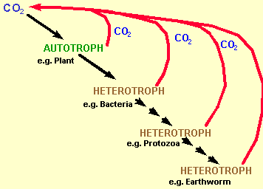

The 4 Phases of Microbial Population Growth
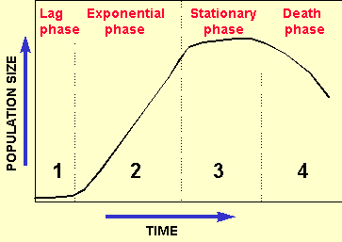
1. Lag phase
This is the time needed to switch on the necessary cell machinery to (a). transport the substrate into the cell, and (b), process the substrate once inside. It normally requires the de novo synthesis of new enzymes and therefore requires gene transcription and translation which will take at least a few hours.
2. Exponential phase
The necessary machinery for substrate use are now in place (the enzymes required to transport the substrate into the cell and the enzymes required to turn this into energy or new cell material). If the substrate is in plentiful supply, growth is very rapid and goes in the following exponential pattern
1 cell…. 2 cells...4 cells….8 cells….16 cells….32 cells
3. Stationary phase
At this point either the substrate or another nutrient (e.g. P or N) has become limiting so that growth is now slowing rapidly as it becomes harder and harder to obtain the limiting factor.

4. Death phase
The cell starts to run out of energy so they start to die.
Now we will talk about two important concepts: Succession and Competition
Succession
Below is a graph showing succession of three groups of organisms. Substrate has been added as time = 0 and bacteria have responded by growing (in 4 phases as described above). As protozoa are triggered into action by bacteria, they don't start growing until the bacteria are in exponential phase. They then go through four phase growth. This is followed similarly by protozoal predators mites. Note that all go through 4 phases of growth and that the population numbers are lower at each stage. Secondly note that the curves start and finish at different times. i.e. the time of death is not the same for bacteria and mites. The 3 curves represent from left to right, bacteria, protozoa and mites respectively.
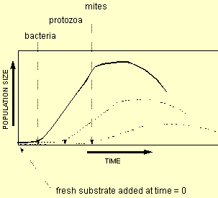
Competition
Here we have on the surface similarly looking graphs for two fungal species. However, it is subtly different and is characteristic of competition. Fusarium is the top curve and Pisolithus the bottom curve. Here the substrate has been added at time = 0 and Fusarium has reacted first. Pisolithus, however, can also use this substrate but it takes longer to turn on the necessary apparatus for transport (maybe it has only a few membrane receptors for this substrate). The important point to note, however, is that they both go into stationary phase and death phase at the same time. This indicates that they are both using the substrate and that Pisolithus is not using Fusarium as a substrate. Basically Fusarium has out-competed (higher population) Pisolithus for the substrate.
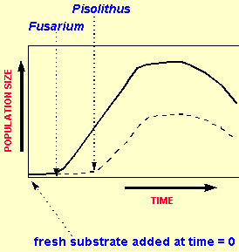
This leads us onto two soil microbiolgical terms to describe fast and slow growers in soil. These are
Zymogenous
Organisms which grow extremely rapidly when a new substrate arrives
The are 'boom' and 'bust' (i.e. big fluctuations in population numbers)
They are not long lived
They spend most of their time in hibernation (waiting for substrate)
They are more adapted to taking up substrate at high concentrations
They are uncommon in soil (as soil is normally substrate limiting)
They are analogous to 'r strategists'
Autochthonus
Organisms which grow slowly when new substrate is added
Their populations tend to be more stable
They are longer lived
They are more adapted to taking up substrate at low concentrations
They are common in soil
They are analogous to 'k strategists'
Below is a graph of the population numbers versus time for each group
